Palo Alto VM Series using ORM stack

Contents

1. Introduction 3
2. Workflow diagram to deploy the stack 3
3. Create stack for Palo Alto VM 4
4. Plan the Job 8
5. Apply the Job 10
6. Verify in the Console 11
7. Destroy the stack 12

Introduction

The Palo Alto Networks VM-Series is a virtualized next-generation firewall that can be deployed in cloud environments, including Oracle Cloud Infrastructure (OCI). It provides advanced security features and capabilities to protect workloads and applications in the cloud.
When deployed in OCI, the Palo Alto Networks VM-Series acts as a virtual firewall that inspects and controls network traffic, enforcing security policies based on application, user, and content identification. It offers features such as intrusion prevention, URL filtering, antivirus scanning, SSL decryption, and application-level visibility and control.
By using the VM-Series in OCI, organizations can extend their security posture from on-premises environments to the cloud, ensuring consistent protection and compliance across their entire infrastructure. It allows them to securely connect their on-premises networks to the cloud and establish secure communication channels between different cloud environments.
The VM-Series supports high availability and scalability, allowing organizations to scale their security resources based on their needs. It integrates with other Palo Alto Networks security products and management tools, providing centralized visibility and control across the entire security infrastructure.
Overall, the Palo Alto Networks VM-Series in OCI enables organizations to secure their cloud workloads and applications while maintaining compliance and adhering to their security policies.

Workflow diagram to deploy the stack

Below diagram shows how the Terraform Artifact are applied in the OCI. While creating a ORM stack, using terraform deliverables Init, Plan and Apply is the flow to provision the resource in the OCI. We can have the deliverables in any of below.

- GitLab/GitHub Repo
- Bitbucket
- Can be in folder/.zip in the local disk
- Object Storage Bucket
- Can be in compartment
- Oracle provided Template

Prerequisites:
- SSH KEY

Create stack for Palo Alto VM

Go to OCI Console Developer Services Resource Manager Stacks select the compartment Create Stack

My Configuration Folder Browse Select the “paloaltovm” folder that contains the terraform Upload

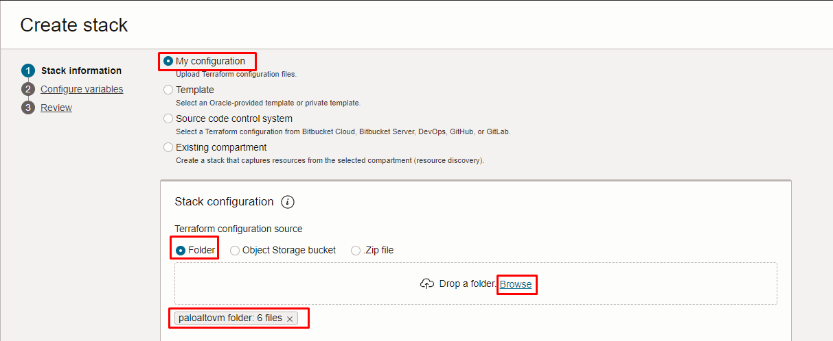

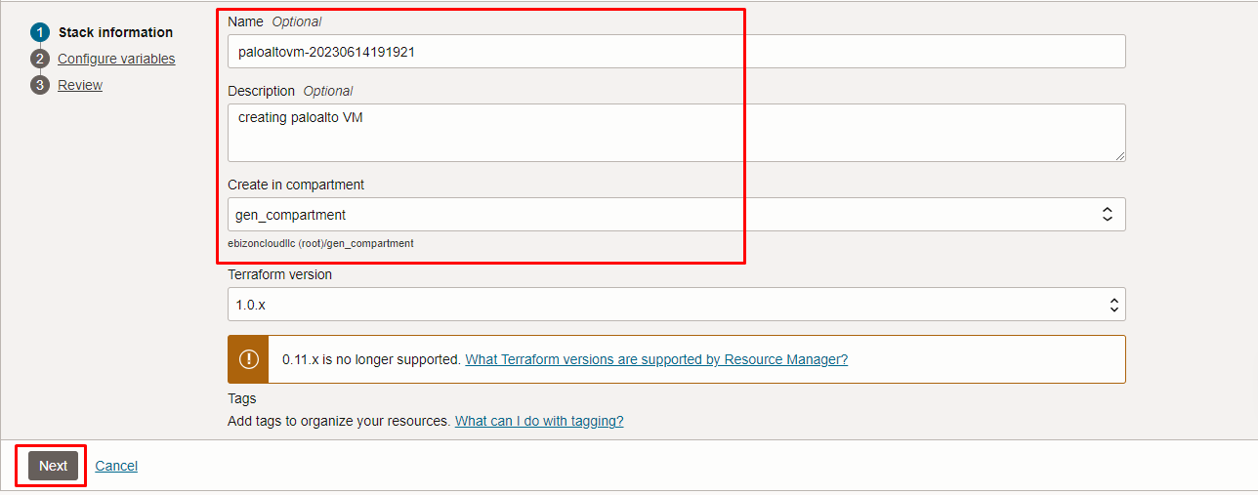

Click “NEXT”
Select the parameters as per the below screen,

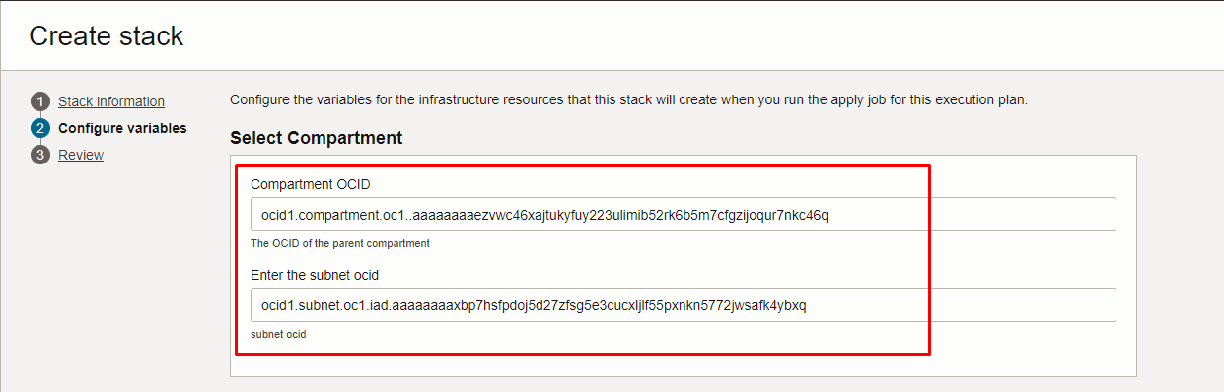

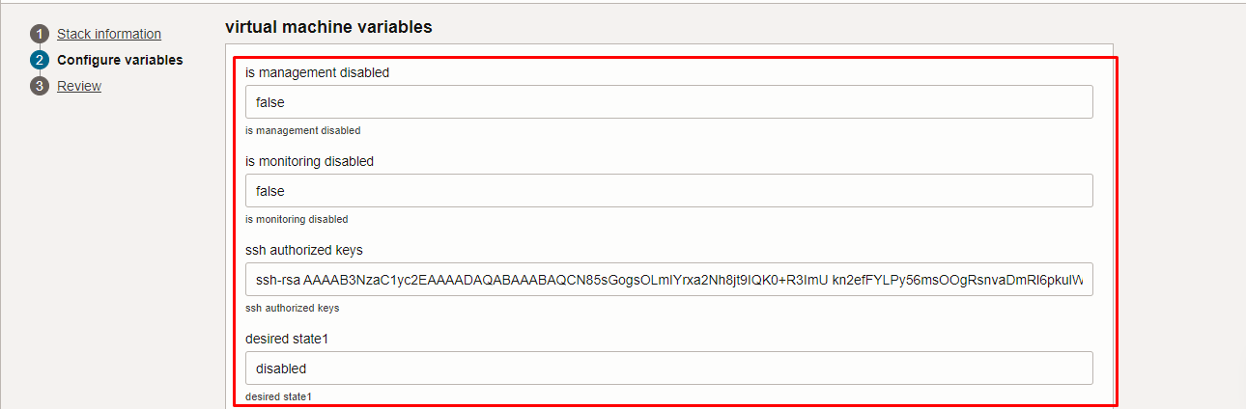

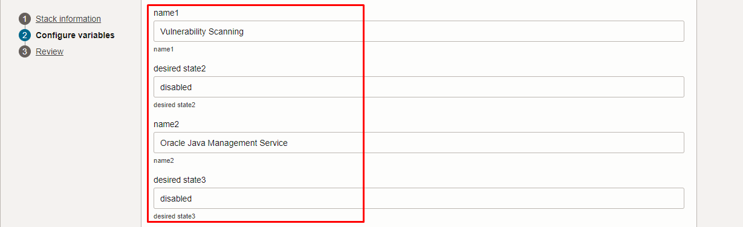

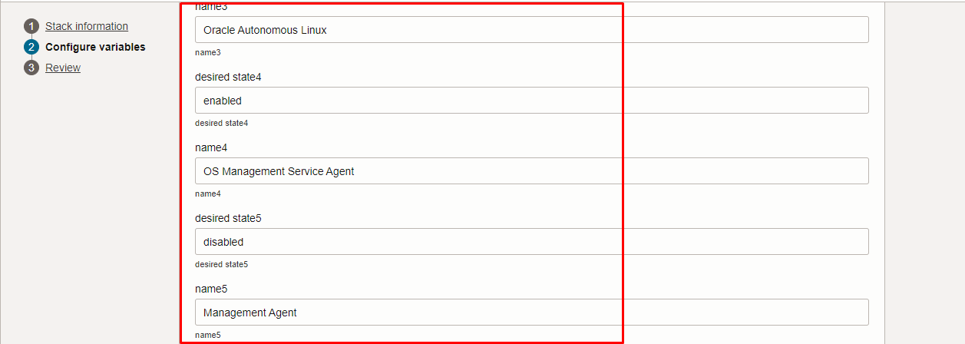
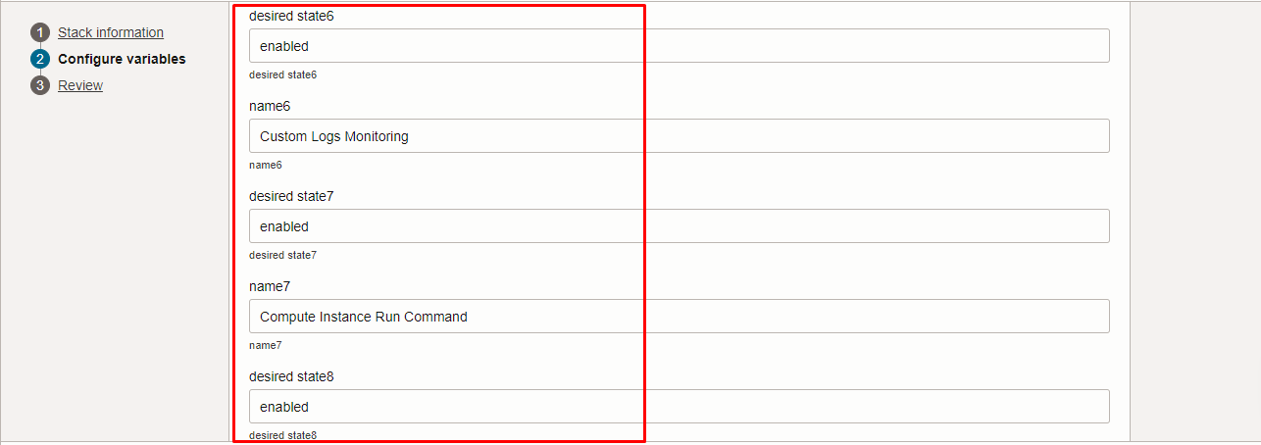

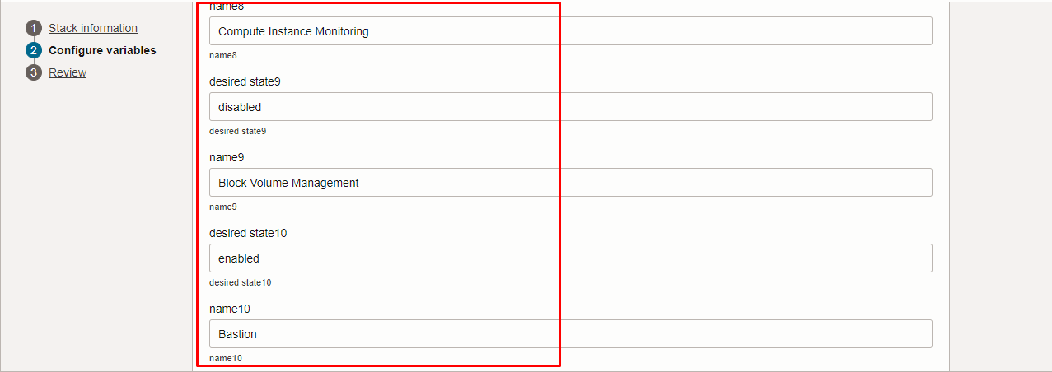

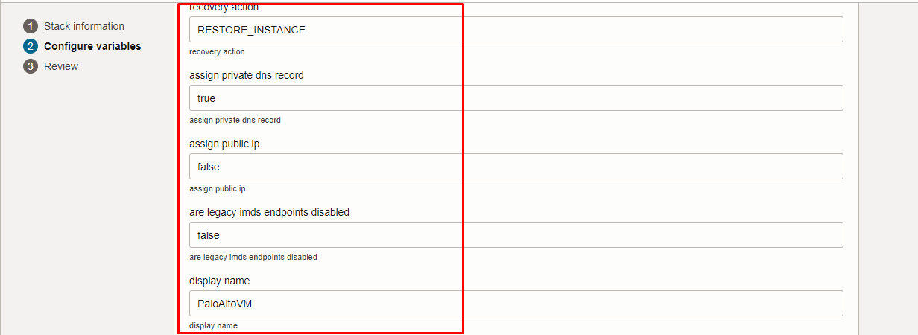
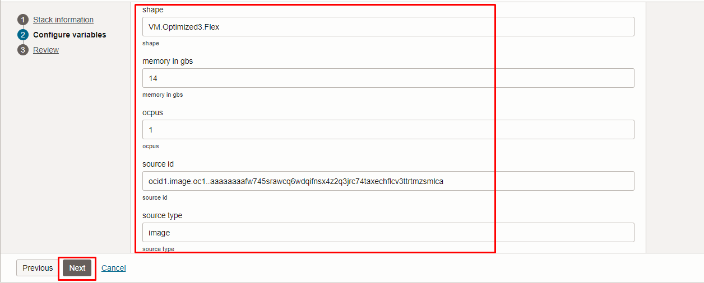

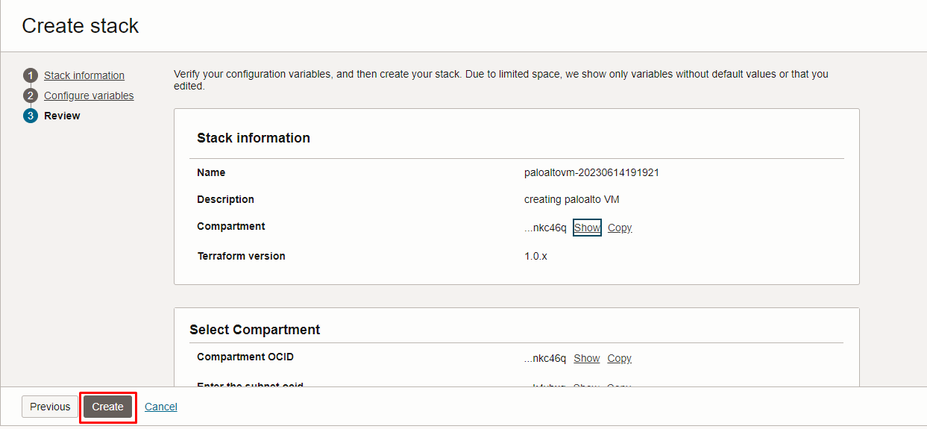

Click “NEXT” Click “CREATE”

Plan the Job

Click the “Plan”

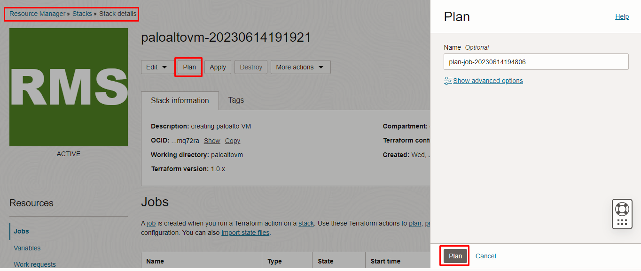

Verify the Plan is successful.

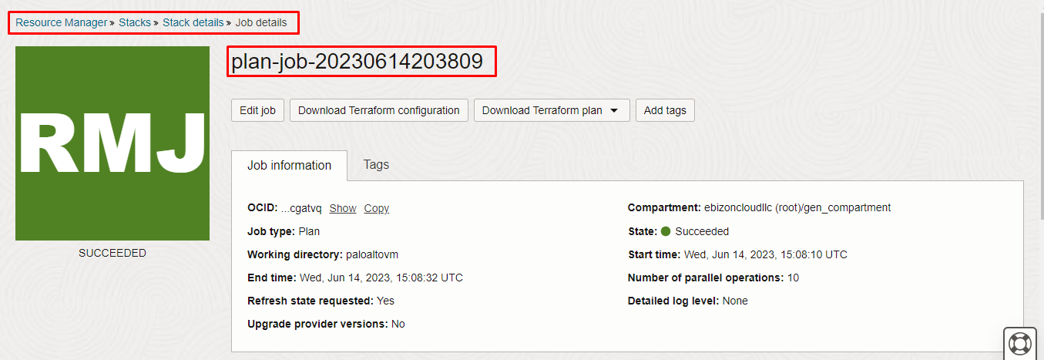

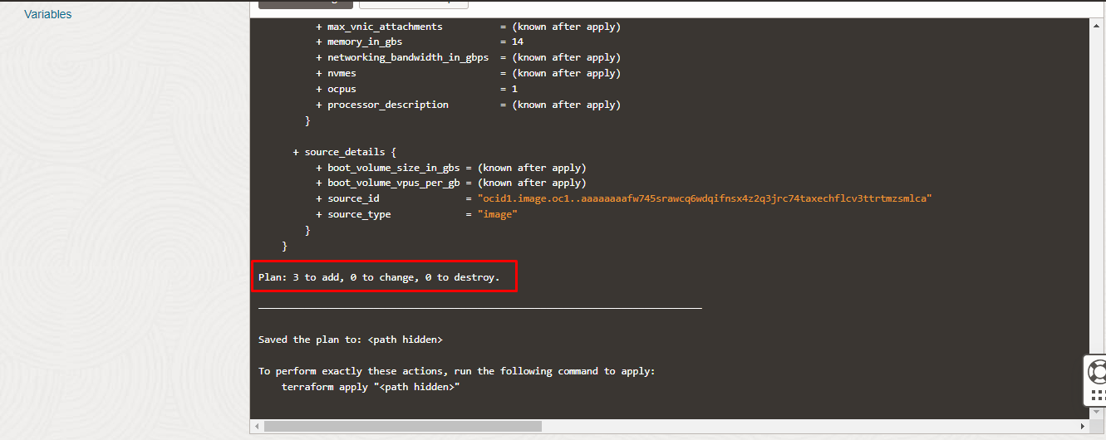

Apply the Job

Once the “plan” is success, now click “Apply”

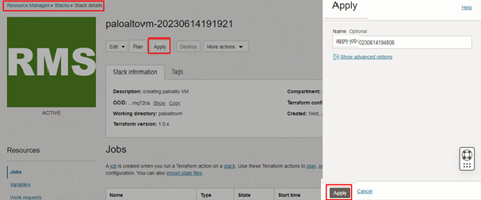

Verify the Apply is successful,

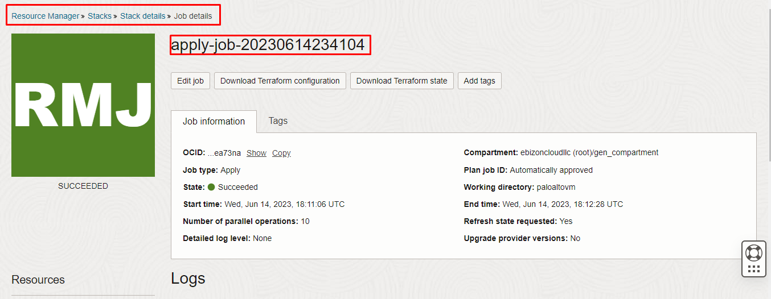

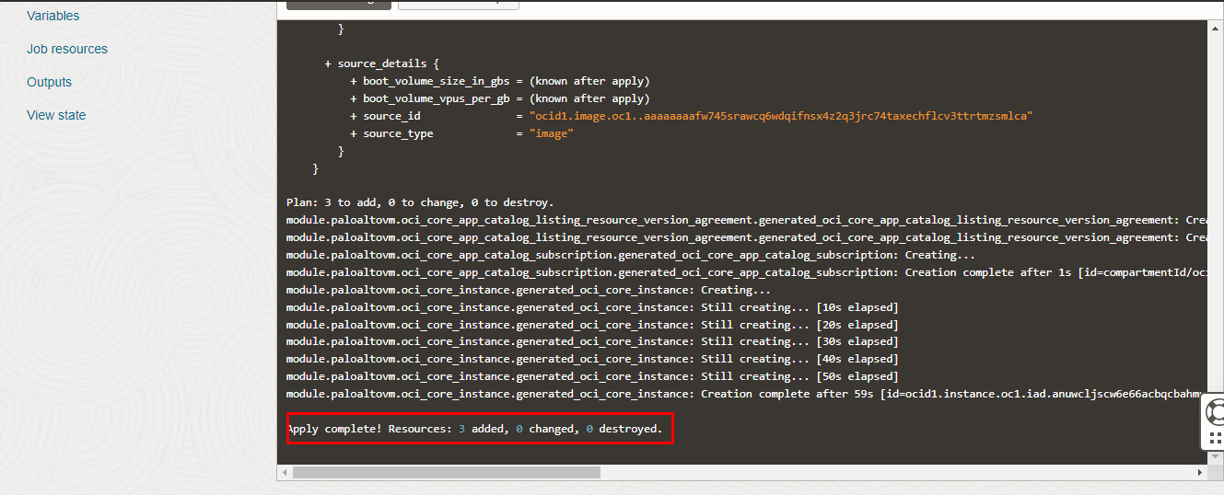

Verify in the Console
Go to OCI Console Compute Instance
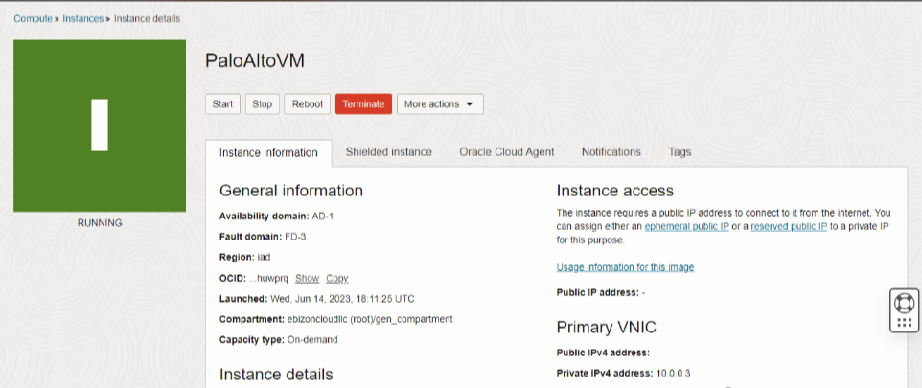

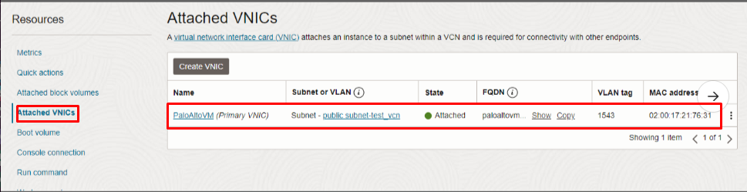

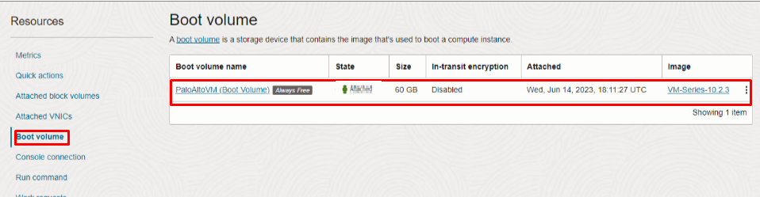

Destroy the stack

Create a destroy job in Resource Manager to release resources associated with a stack and clean up the tenancy. Once destroyed data cannot be recovered from resources.

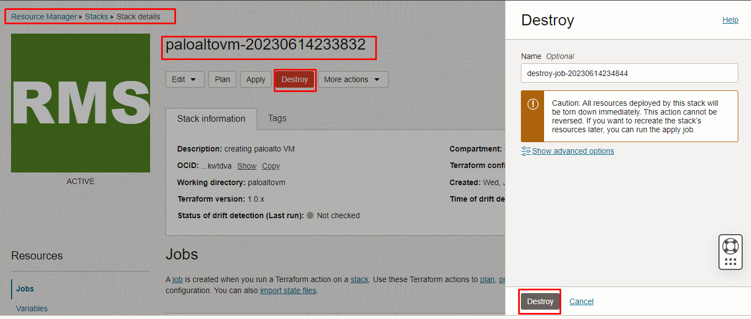
####END####

